|  |
| --- |
| Circle Language Spec: Commands |

## Private Objects in a Command Call in a Diagram

This article demonstrates a situation of command objects.

This article illustrates how private objects in a command call look in a diagram.

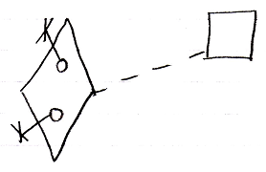

The diamond is a command call. Its definition is indicated with the dashed line connecting it to the square, which is the definition. The circles inside the diamond are the private objects of the command call. The fact, that they are private is displayed with the object line and the cross it ends with indicating, that you can not reference these objects from the outside.

Another possible expression of the private objects is the following:

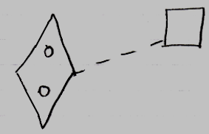

Because public object, parameters, always come with an indication of the parameter passing, you may not need to express the objects’ being private, because it would be obvious: if they do not have a parameter passing, then they are private.